**Review - Structure of the Earth**

1. Label the diagram below with the following words:

crust, mantle, inner core, outer core

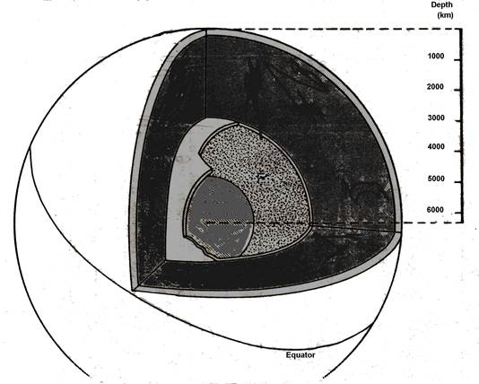

1. Using your textbook or laptop, record the features of each layer of the geosphere in the table below.

|  |  |  |  |
| --- | --- | --- | --- |
| Layer | Depth | Temperature | Made Of |
| Crust |  |  |  |
| Mantle |  |  |  |
| Outer Core |  |  |  |
| Inner Core |  |  |  |